NEPCON ASIA 2025: Innovating Smart Manufacturing Ecosystems and Bridging Global Opportunities
Taking place from October 28 to 30, 2025 at the Shenzhen World Exhibition & Convention Center (Bao’an), NEPCON ASIA is the premier platform to discover the latest technologies and market trends, connect with new suppliers and products, and explore potential partnerships and distribution opportunities.
Featuring an ever-expanding showcase of automation equipment and technologies, the show empowers you to optimize your supply chain, reduce costs, and ensure quality and yield — all driving sustained growth in the electronics manufacturing industry.
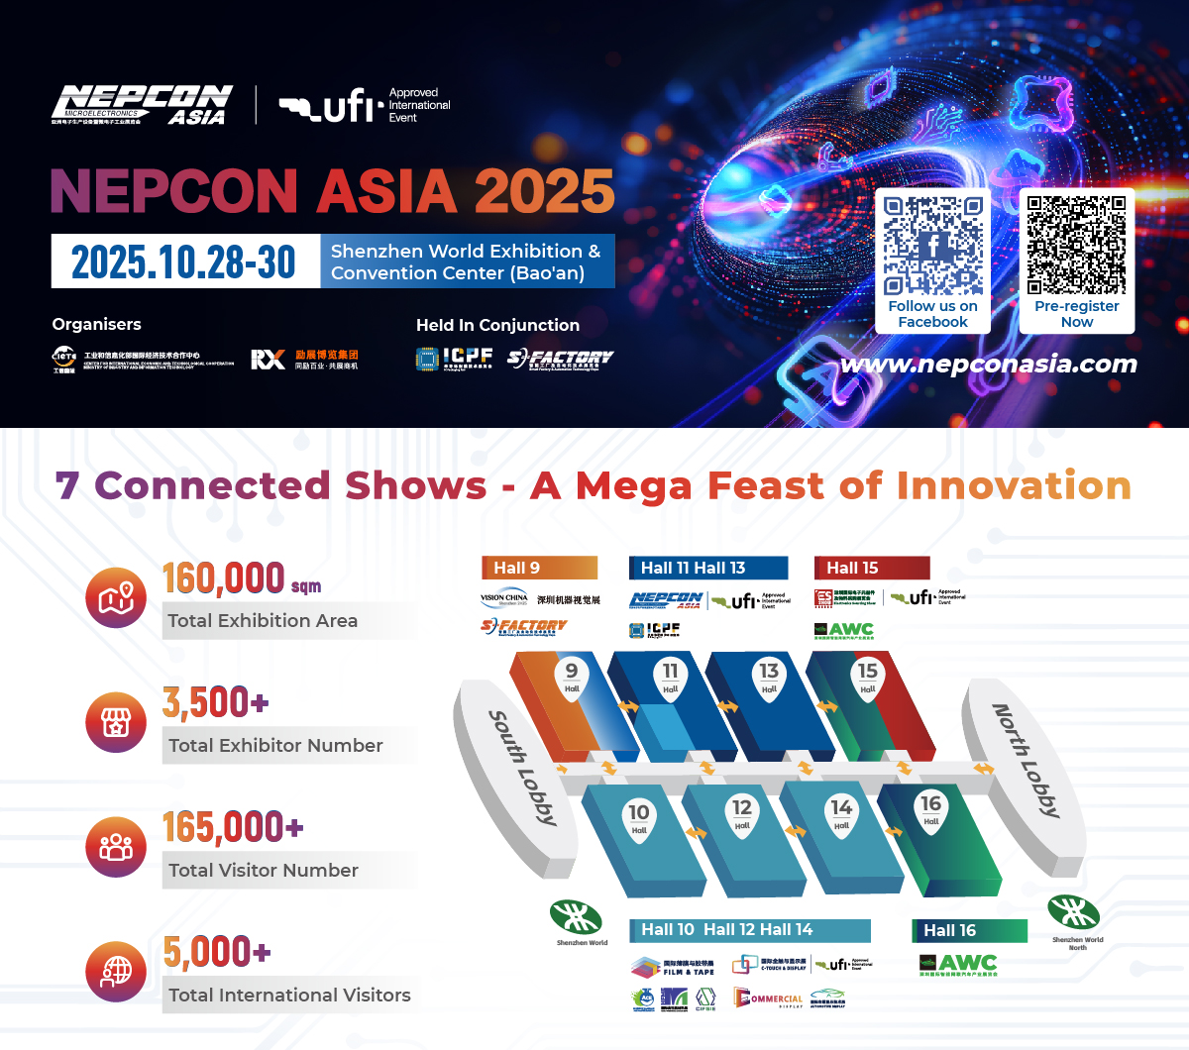

Hundreds of New Product Launches
NEPCON ASIA 2025 will showcase hundreds of new products and solutions across SMT, testing and measurement, soldering, dispensing, semiconductor packaging, and automation. The show will feature over 600 leading exhibitors, including Yamaha, Hanwha, Fuji, Kurtz Ersa, Rehm, Tamura, Koh Young, TRI, ALEADER, Unicomp, Anda, and Axxon, connecting them with millions of buyers from high-growth sectors such as automotive electronics, semiconductors, and new energy.
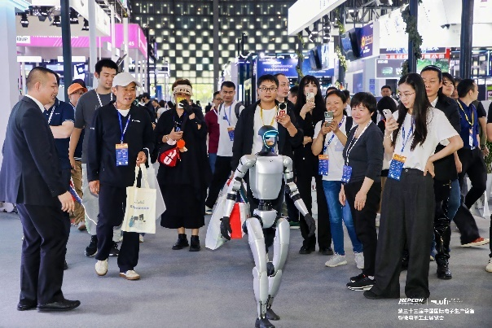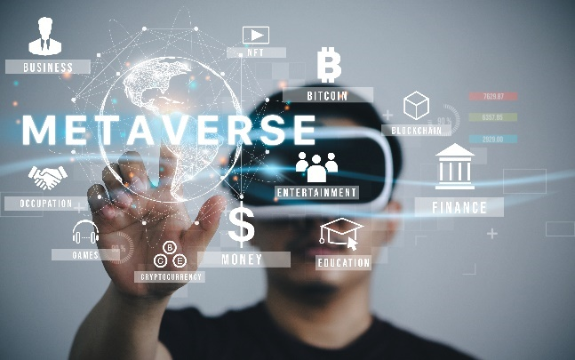

Breakthrough Areas Driving Innovation
Several standout themed areas will debut, integrating industry resources and cutting-edge technologies, while showcasing packaging, testing, flexible manufacturing, assembly, and key components.
Key themed areas include:
- AI Smart Glasses Disassembly Area
- Flexible Manufacturing and Intelligent Transport System Area
- Low-Altitude Flight Components Disassembly Area
- Embodied Intelligence Robot Core Parts Disassembly Area
- Electronic Finished Products Automated Packaging Demonstration Area
- IGBT & SiC Packaging and Testing Demo Line
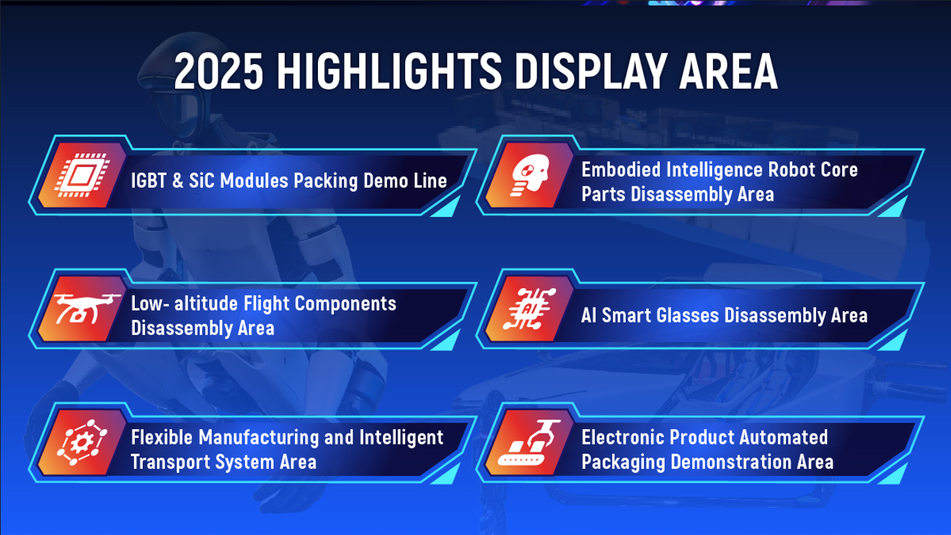

Conferences Empowering Industry Growth
NEPCON ASIA 2025 will host 40 high-level conferences covering advanced manufacturing, semiconductors, power electronics, robotics, and AI, empowering businesses to explore future technologies and seize new growth opportunities.
The SMTA South China High-Tech Workshop will feature global experts from China, the US, Japan, and Thailand, providing forward-looking insights for businesses.
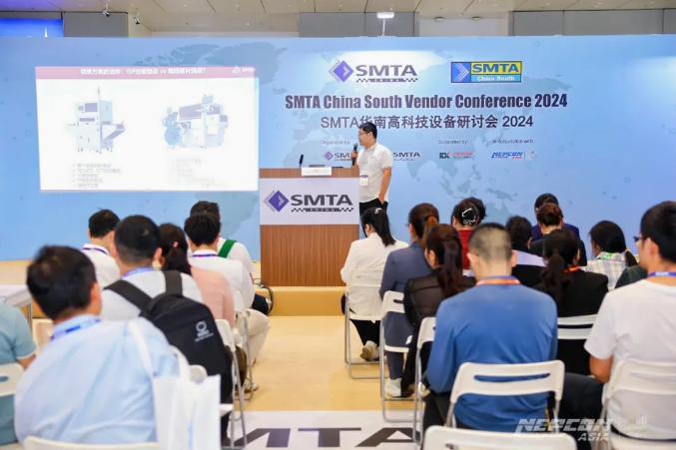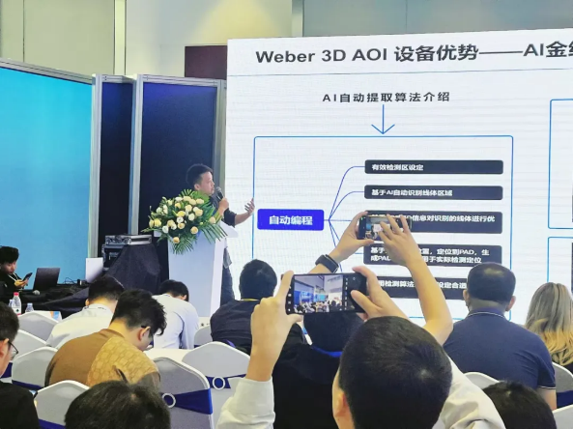

Connecting Global Markets
As China’s technology and manufacturing hub, Shenzhen offers a complete electronics ecosystem and unmatched supply chain advantages, providing exhibitors and visitors with opportunities to access its thriving industry cluster.
Through collaborations with overseas industry associations across Southeast Asia, the event will organize factory tours, business matchmaking and overseas networking salons, fostering deeper integration between Chinese and global electronics manufacturers.
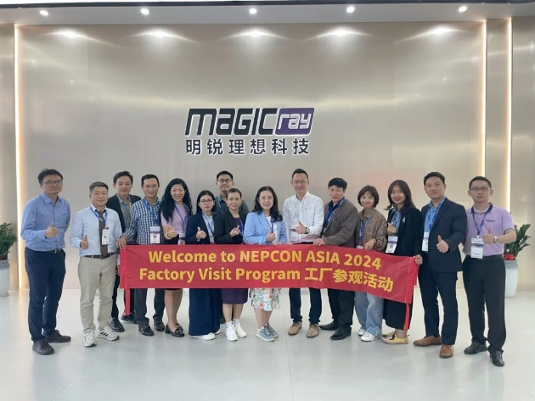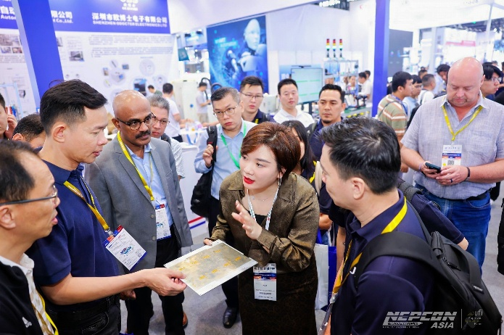
Visitor pre-registration is now open! Benefit for overseas Visitor Groups From NEPCON ASIA 2025：Complimentary hotel rooms、Shuttle bus to pick up、Networking Lunch、VIP Visitor pass、Factory Visit、1 on 1 Business Matching、Country Day Program and so on, Lock in your front-row seat to tomorrow, capture new opportunities, explore emerging markets, and enhance global competitiveness.
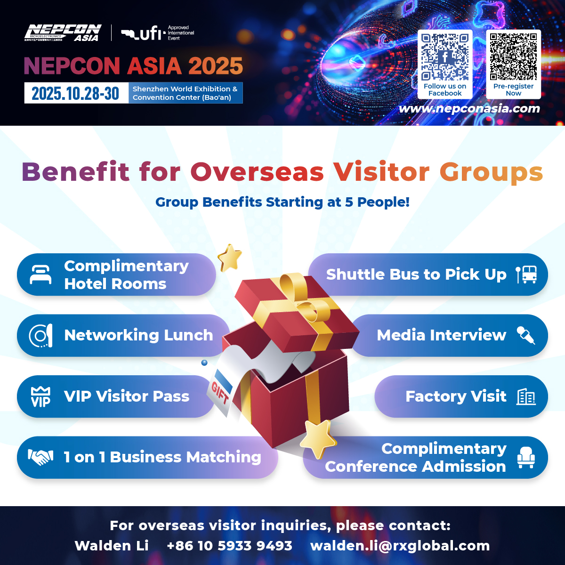

For visiting inquiries:
Walden Li | Email: walden.li@rxglobal.com
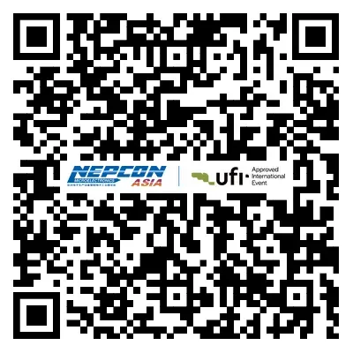
For exhibiting inquiries:
Julia Gu | Email: julia.gu@rxglobal.com
Pre-registration link：https://ali2.infosalons.com.cn/reg/NEPCON25SZ/registeren/login?type=Z0AR7L
For more information, please visit NEPCON ASIA - Six Electronics Trade Shows Under One Roof.
Facebook: @NEPCONASIA
LinkedIn: @NEPCON ASIA
About RX
RX is a global leader in events and exhibitions, leveraging industry expertise, data, and technology to build businesses for individuals, communities, and organisations. With a presence in 25 countries across 42 industry sectors, RX hosts approximately 350 events annually. RX is committed to creating an inclusive work environment for all our people. RX empowers businesses to thrive by leveraging data-driven insights and digital solutions. RX is part of RELX, a global provider of information-based analytics and decision tools for professional and business customers. For more information, visit www.rxglobal.com.

